Travel blog: Discover cozy Winnipeg with me.
Are you searching for the ideal city that offers you everything you are looking for? I may have the perfect find, as this great city offers both employment opportunities and impeccable infrastructure. Hesitating because of the people you’re about to leave behind? No stress, because Winnipeg is known for its ideal mix of social contact and friendly ambiance.
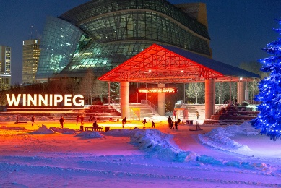
Winnipeg is the capital of the province of Manitoba, located in the South, which has about 750 000 inhabitants. In this city you can quickly make a nice stopover during a trip, due to its ideal location. Located on the edge of the Canadian Prairies, the area is known as the "Gateway to the West". Despite the city's size, it does have the coziness found in a small town. Everyone knows it; the lights that twinkle on the roads during the holidays, the squares where one finds cafes, the historic buildings,... The city was not nicknamed "Winterpeg" for nothing, it was linked to the most cozy period of the year. Due to the harsh winter, which takes almost 5 months there, you can enjoy the coziness that Christmas brings longer. Just imagine stepping on fresh diamond dust, which takes all of your worries away. As the beautiful rivers the 'Red river' and the 'Assiniboine river' freeze over, you can skate and cross-country ski a course of more than 10 km here. Now admit it, there's nothing quite as cozy as drinking a hot chocolate at the skating rink, is there?
The long winter season not only provides coziness, but also helped the city to flourish. Thanks to the fur trade, which was established by French settlers in 1738, the area grew into a successful trade centre, allowing it to grow and develop even more. This trade was successful not only because many fur coats were needed for the harsh winter, but also because of its convenient location on both rivers. On November 8, 1873, this area was officially declared the city of Winnipeg.
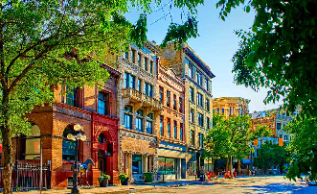
Even today, Winnipeg is still a thriving city where you can still see very beautiful remnants of its history, giving the city a rustic charm. For example, you have the Exchange District, which is even hipper than wearing wide pants. In this bustling neighbourhood, you will find a collection of historic buildings built in the 19th and 20th century. Formerly home to financial institutions, these buildings have been transformed into Winnipeg's cultural centre. The district wasn't nicknamed "the Chicago of the North" for nothing, named after one of the most vibrant and popular cities in America.
Since 1873, the city has not only grown into a beautiful and authentic area, but it also provides space for the development and talent development of its residents. Thus, it gives wide access to art, music and dance. With numerous art museums, you can fully engage your senses and learn about the various art forms here. For example, you should definitely visit the 'Canadian Museum for Human Rights' not only for the beautiful building, but also to discover more about the former indigenous people and the development of Canada. Also, the 'Royal Winnipeg Ballet School' offers future ballerinas a great opportunity.
When you turn the page on Winnipeg, you will find that this city is more than a destination; it is a story that continues to evolve, a canvas of cultures and opportunities. Explore this vibrant city, because Winnipeg will always invite you to a new adventure, where history meets the future. In Winnipeg, where every corner tells a story and every smile is a greeting, your journey is just beginning.

